**Cloud RUN**

**LAB: DEPLOYING A SAMPLE LAB in a container**

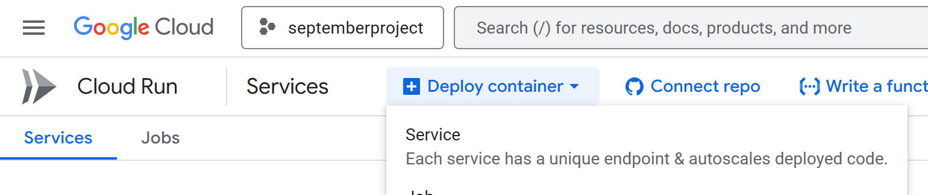



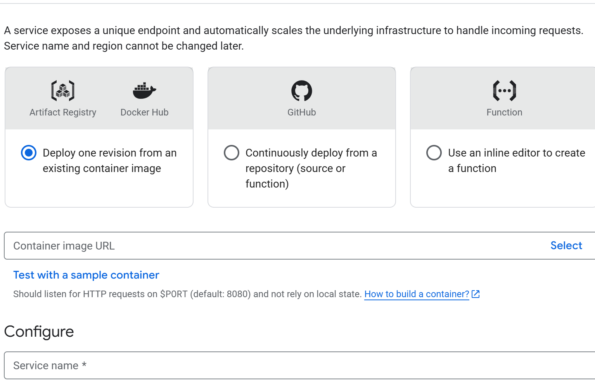



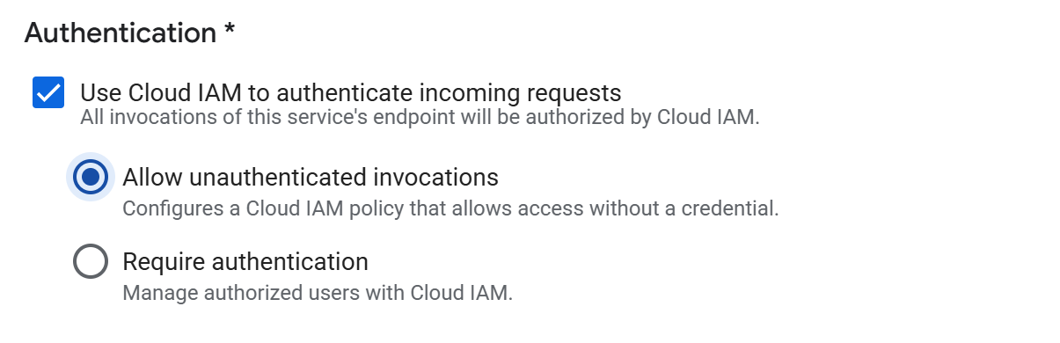

Request-based billing charges per request, for instance startup, when instances are processing requests, and instance shutdown.

Instance-based billing charges for the entire lifetime of container instances.

The selected billing option does not affect Cloud Run's scaling. In any case, Cloud Run scales to zero if min instances are set to 0 and there no traffic is received.

The selected billing option affects how the CPU is allocated to container instances:

* With request-based billing, CPU is only allocated during request processing
* With instance-based billing, CPU is allocated for the entire container instance lifecycle.

Create

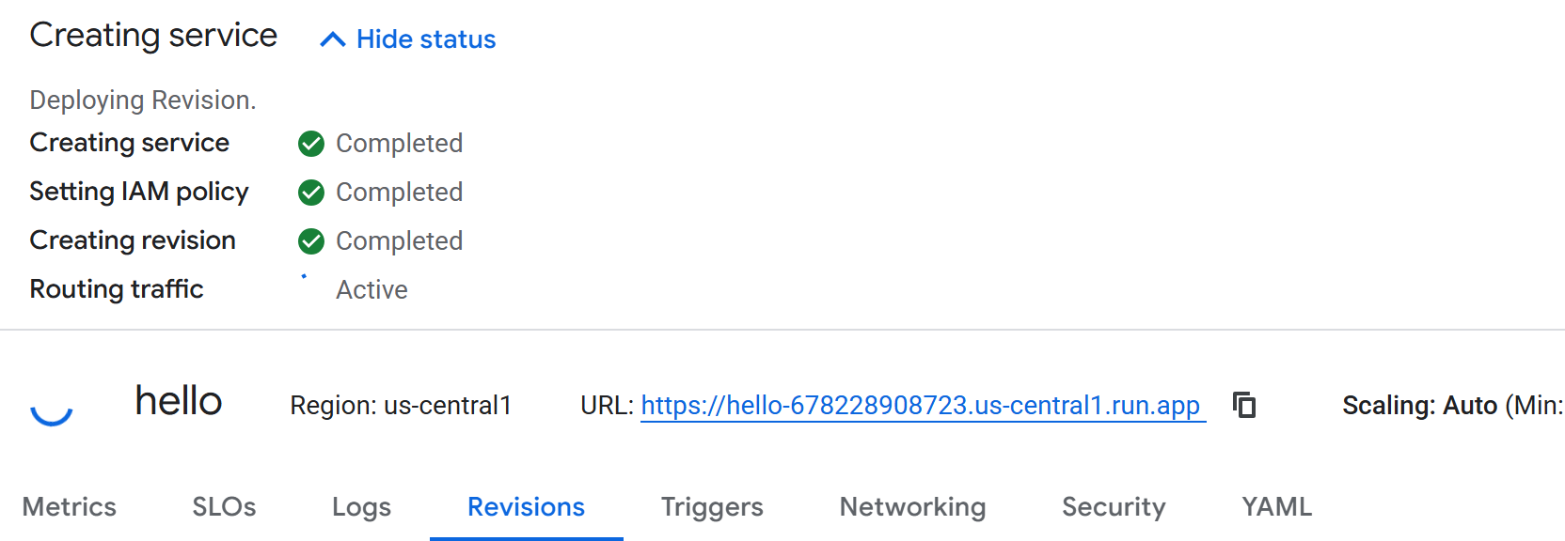



After deployment is completed

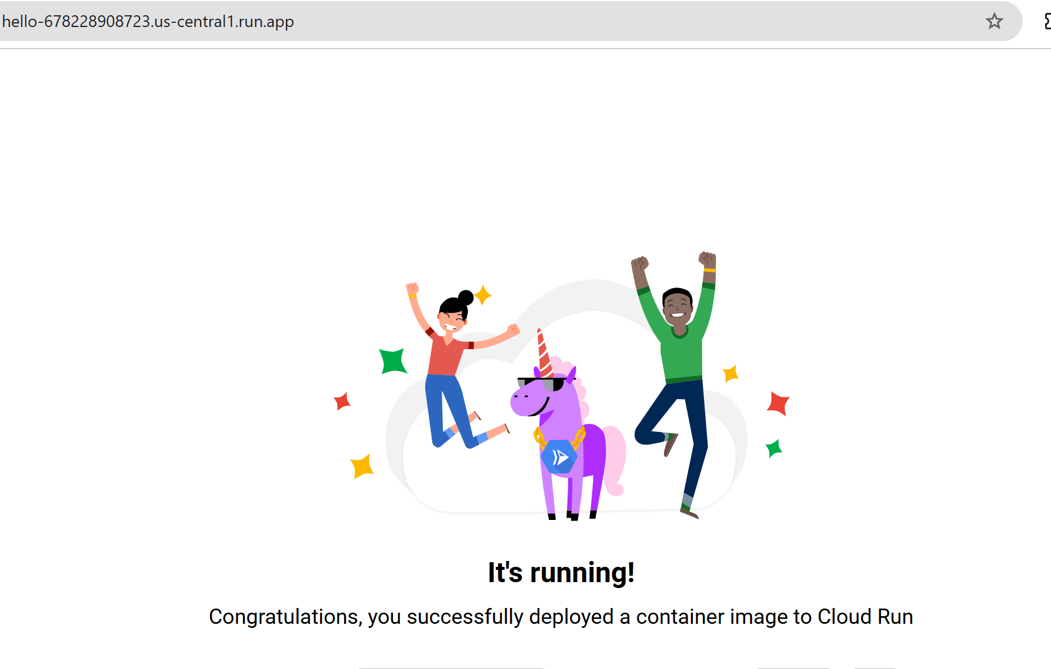

Copy the url and paste it in browser

**LAB 2 : WE WILL DEPLOY A CUSTOM APPLICATION ON A CONTAINER**



**Open Cloudshell**





**git clone** [**https://github.com/akshu20791/cloudrun**](https://github.com/akshu20791/cloudrun)



gcloud builds submit -t [gcr.io/$DEVSHELL_PROJECT_ID/cloudrun](http://gcr.io/$DEVSHELL_PROJECT_ID/cloudrun)

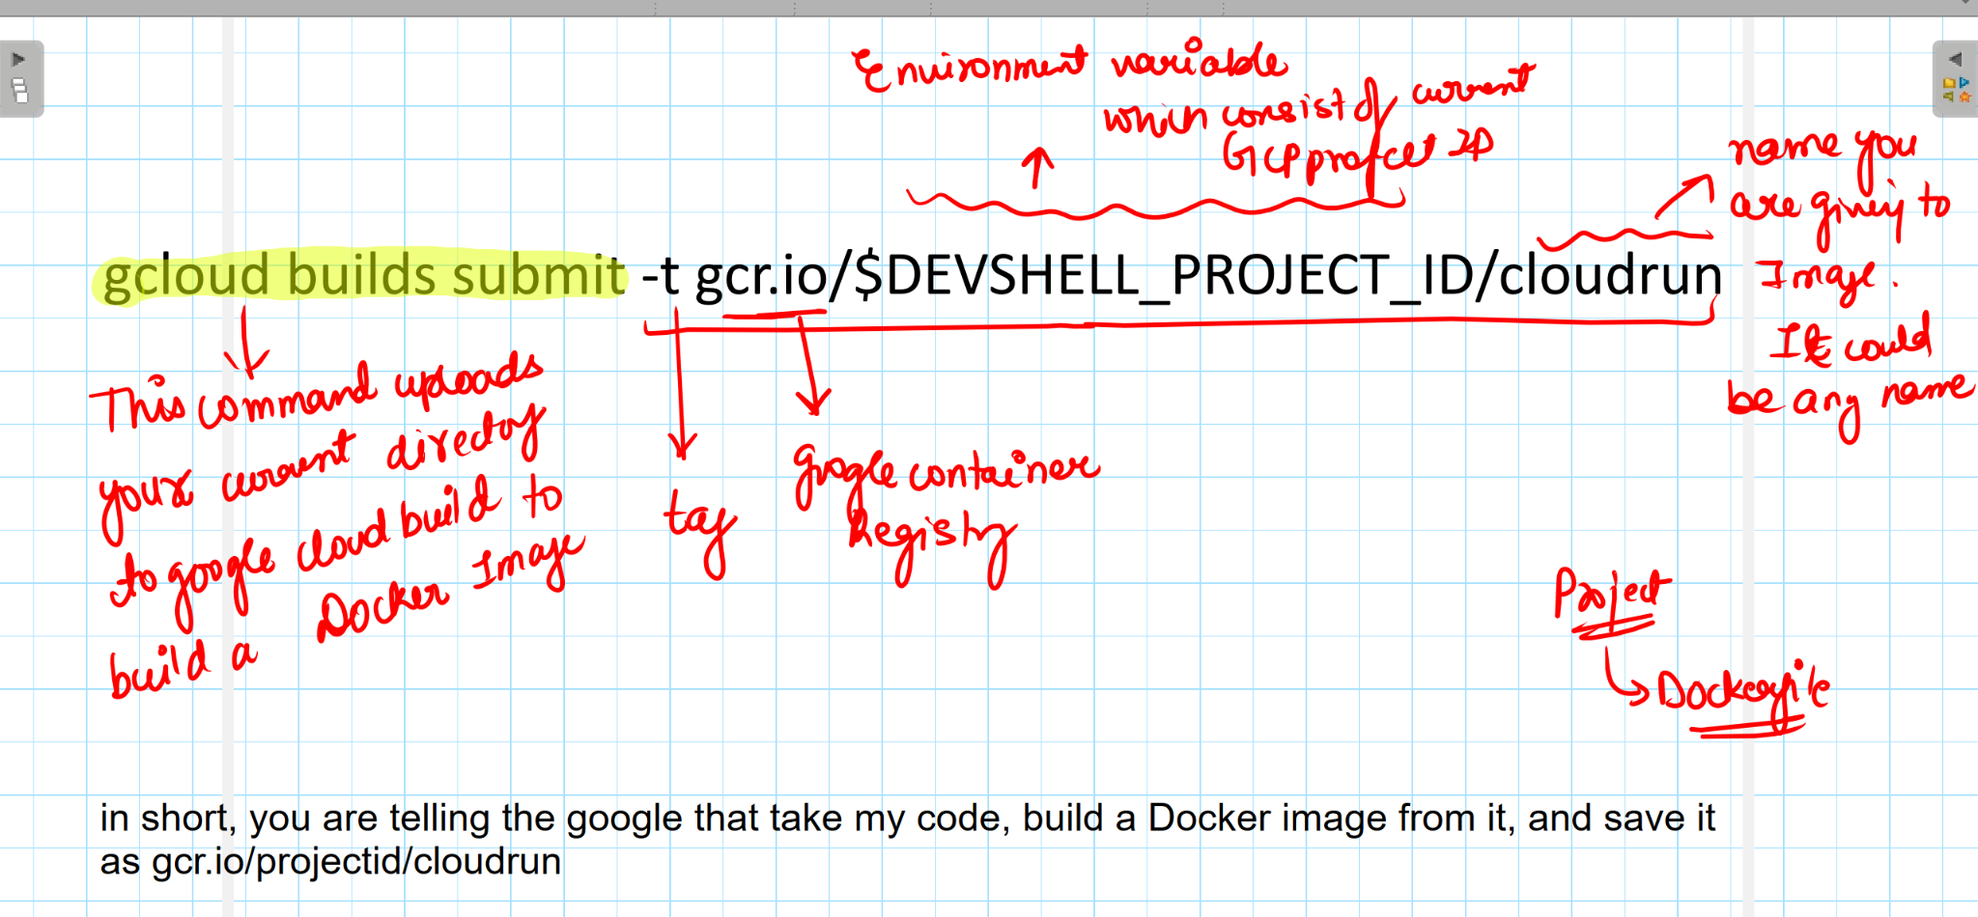



Lets now deploy this new version of app

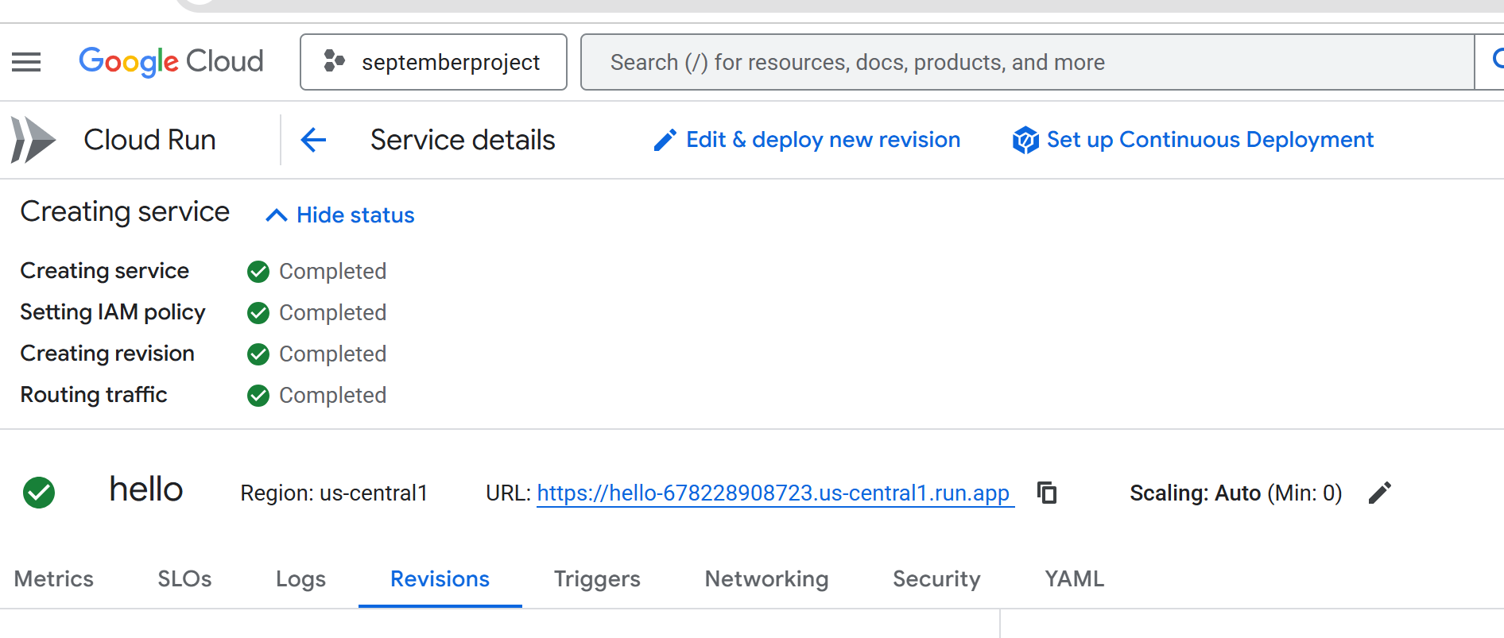



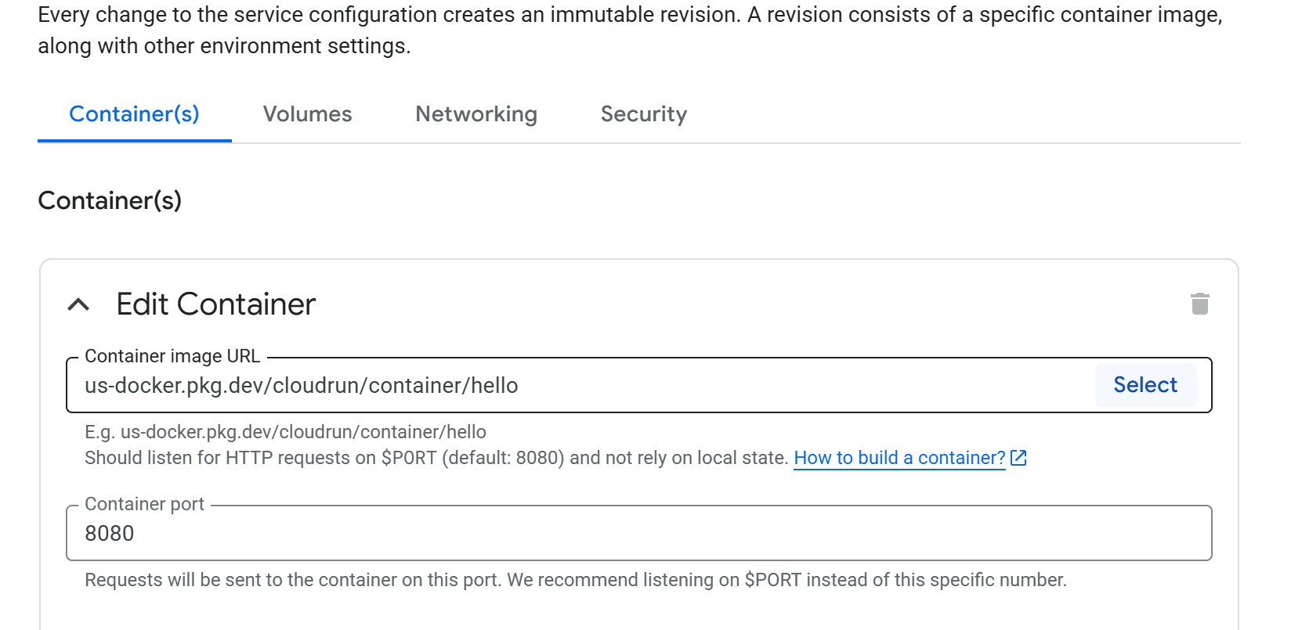  
on the right side a pop up will come



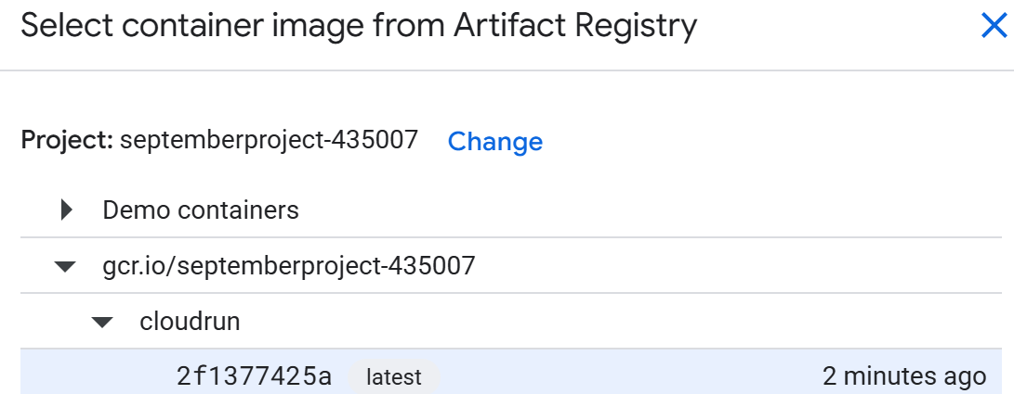Select  
Deploy

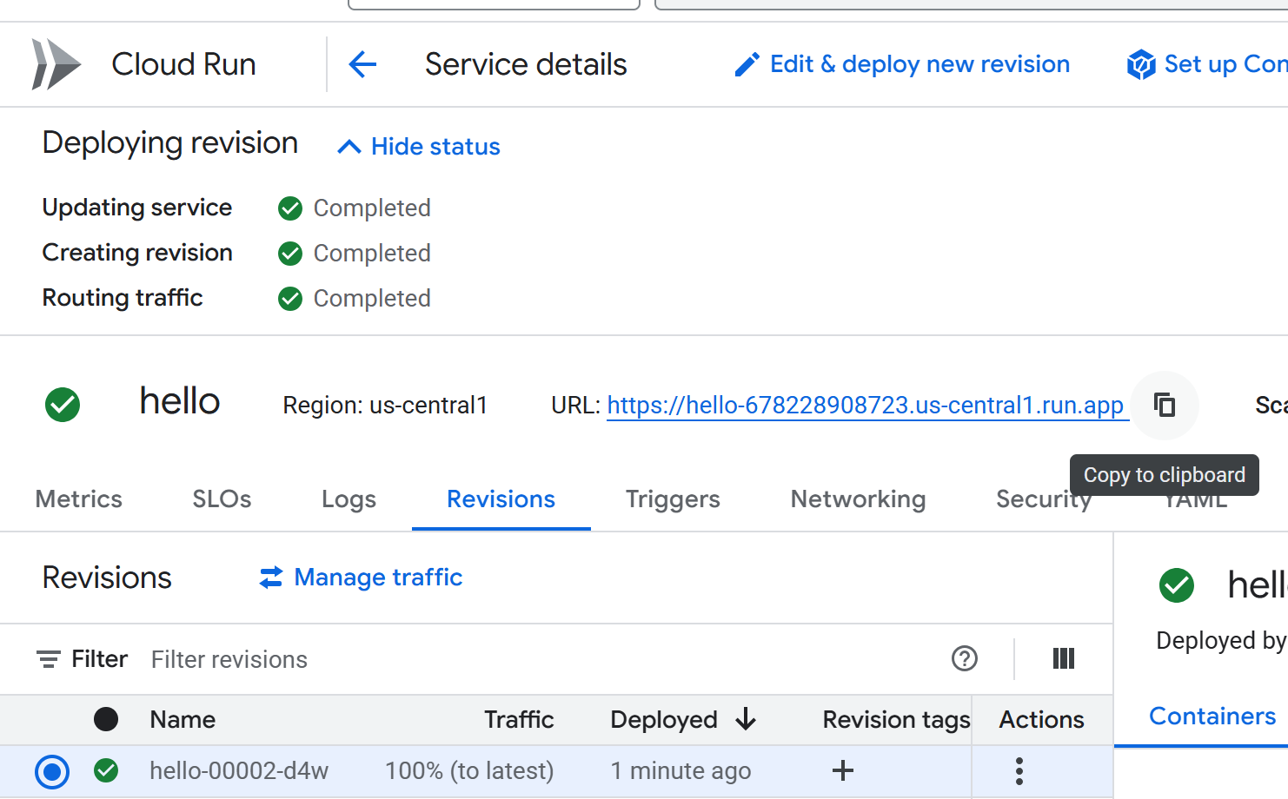   
  
  
 **## LAB 3 : NOW WE NEED TO DEPLOY THE NEW VERSION OF THE APP**



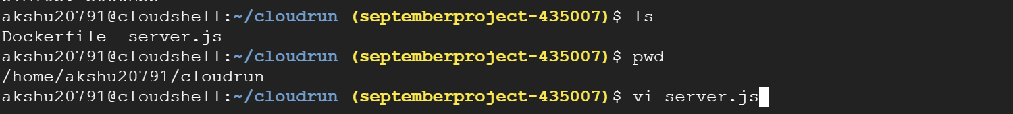

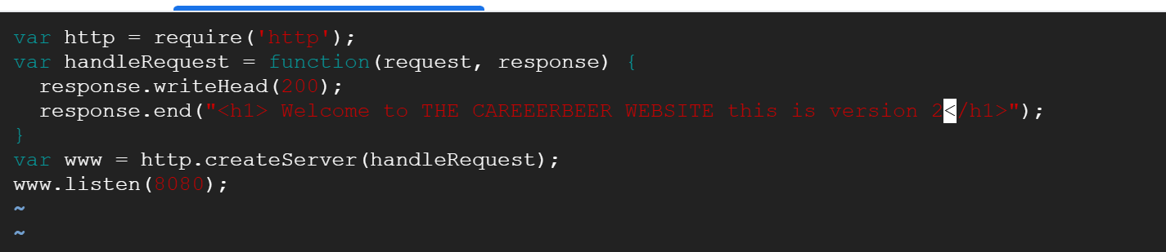



**gcloud builds submit -t gcr.io/$DEVSHELL_PROJECT_ID/cloudrun:v3**

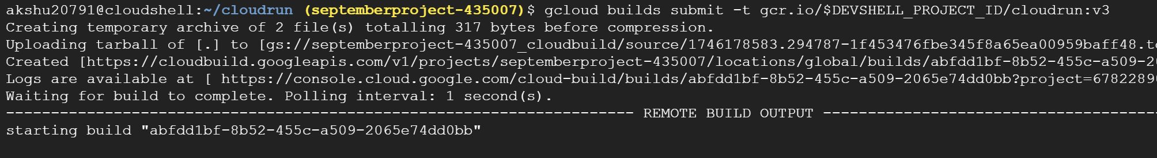

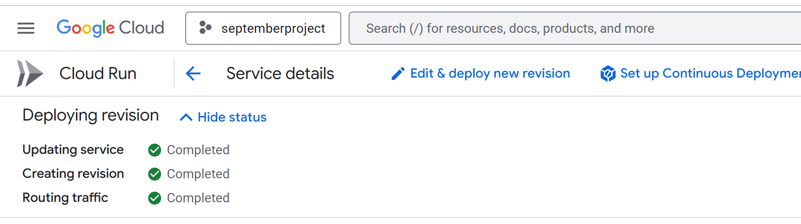



Click on select

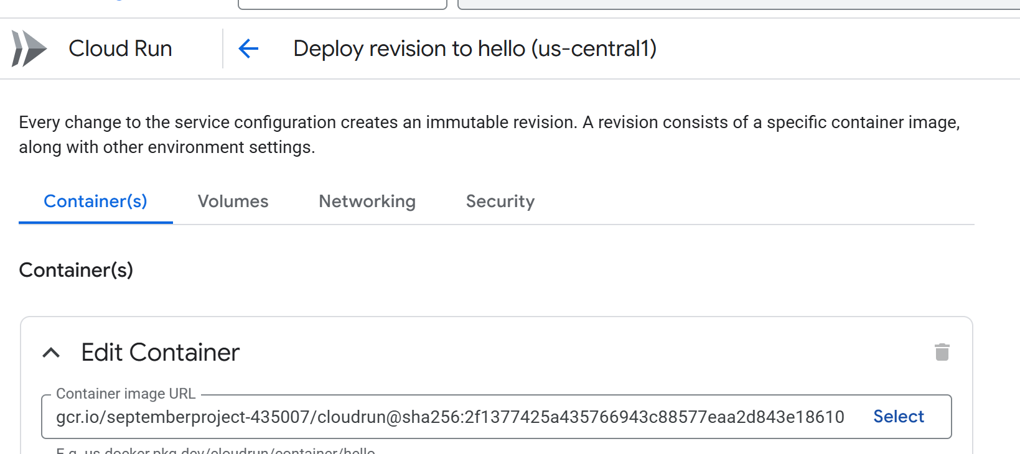



Refersh the page

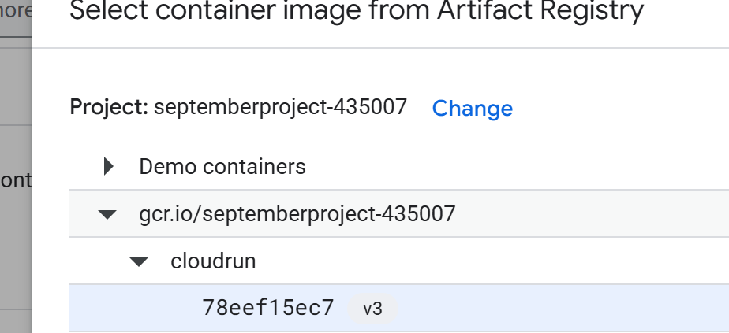

Deploy

You will see the latest website

